# Getting Started Guide – Bank Transaction Categorisation Tool

Welcome! This guide will walk you through using our user-friendly tool, designed to help you effortlessly categorise your bank transactions. You don't need any technical expertise – just follow along!

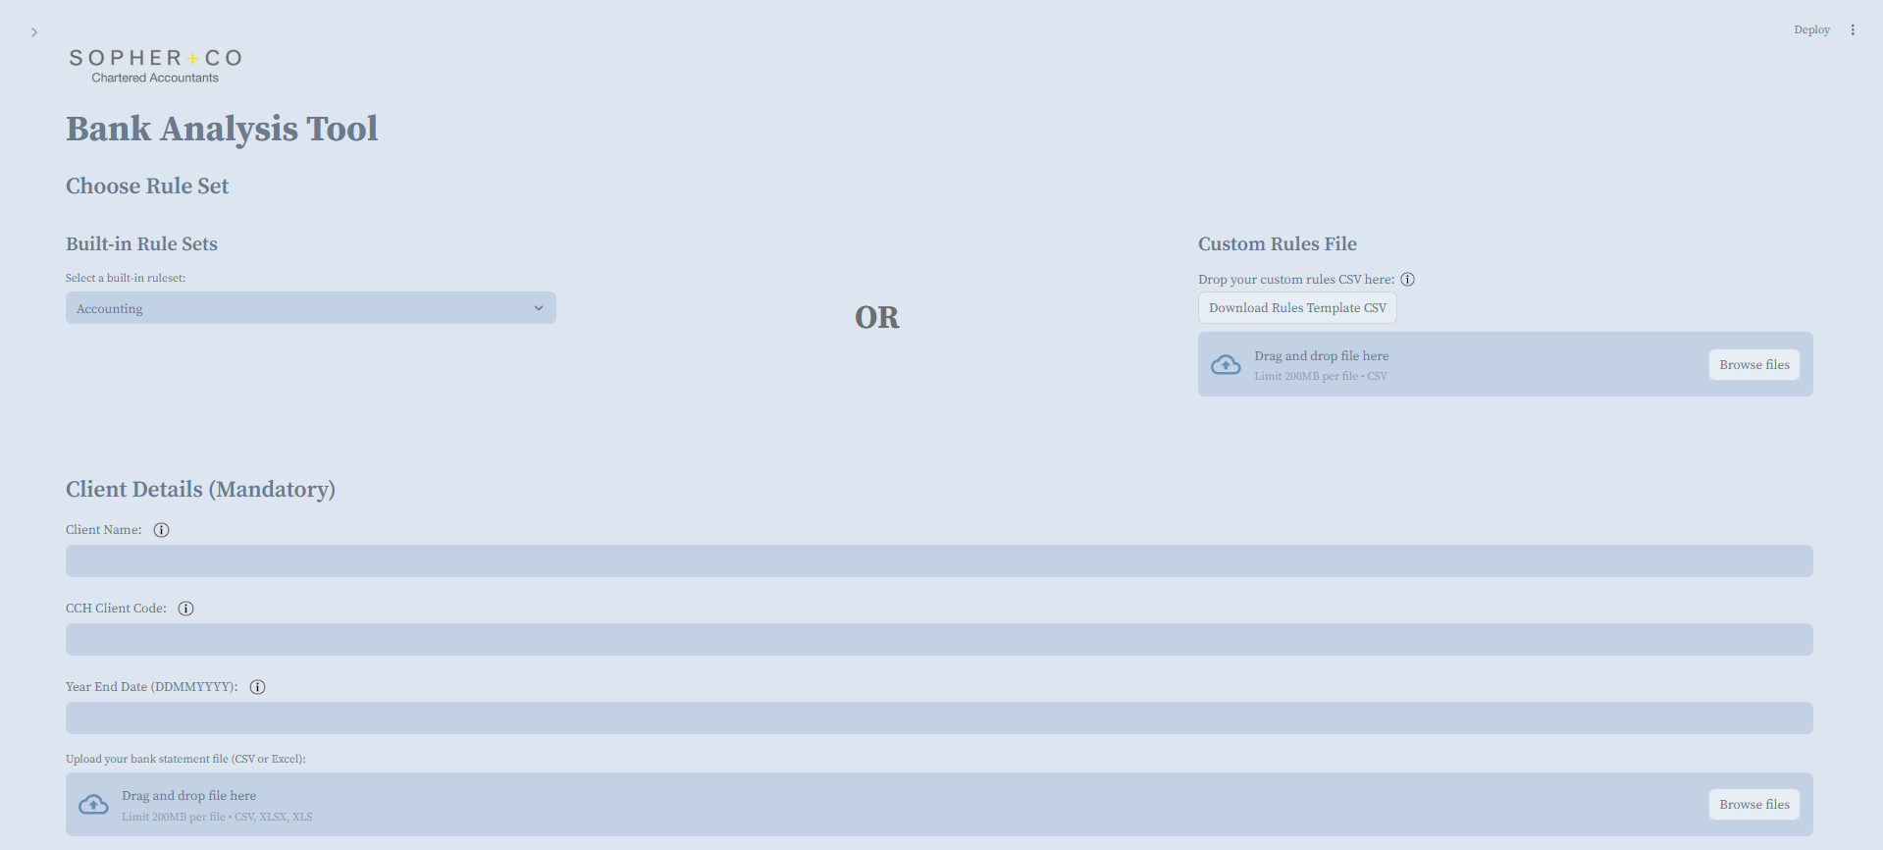

## What This Tool Does

Our Bank Transaction Categorisation Tool is designed to simplify your financial data management. Here’s what it can do for you:

* **Data Cleaning:** It processes and cleans your uploaded bank statement data.
* **Smart Categorisation:** It automatically assigns categories to your transactions based on intelligent matching rules. For example, "Uber" might be categorised as 'Travel', and "Tesco" as 'Groceries'.
* **Easy Download:** It allows you to download a refined file with all transactions neatly categorised, ready for your use.

## Before You Begin

Before you start, please ensure you have the following ready:

* **Your Bank Statement File:** This should be in one of the supported formats: CSV, XLSX (Excel), or XLS (Excel).

* **A Rule Set:** You'll need either:
  + A custom rules file that you've prepared.

* + Alternatively, you can simply use one of the convenient built-in rule sets provided directly within the tool.

## Step-by-Step Instructions

Here’s a simple, step-by-step guide to categorising your bank transactions:

### 1. Pick a Rule Set

You have two flexible options for selecting your categorisation rules:

* **➤ Use a Built-in Rule Set:**
  + Simply select your preferred rule set from the "Built-in Rule Sets" dropdown menu available in the application.
* **➤ Use Your Own Rules File:**
  + If you have specific categorisation needs, you can upload your own custom rules. Your CSV file should have two columns: Description and Category. Each row will define a matching rule, like this:

* + A template for this file can be downloaded directly from the app for your convenience.

### 2. Enter Client Details

This information helps in automatically naming your output files for easy identification. Please provide:

* **Client Name:** This can be your name, your client's name, or any descriptive name you prefer.
* **CCH Code:** A short identifier, typically 3 to 10 characters long (e.g., ABC123).
* **Year End Date:** Enter the date in DDMMYYYY format (e.g., 31122024 for 31st December 2024).

### 3. Upload Your Bank Statement

* Click the **"Upload"** button and choose your bank statement file.
* **Supported formats** include CSV, Excel (.xlsx), or legacy Excel (.xls).
* If your Excel file contains multiple sheets, the tool will prompt you to select the relevant one.
* **Important:** Ensure your file has a column titled **"Description"** where the transaction details (e.g., "Uber Eats 01234") are listed. This column is crucial for the categorisation process.



### 4. Click “Run Categorisation”

Once your rule set, client details, and bank statement are in place, click the **"Run Categorisation"** button. The tool will then perform the following actions:

* It will read and process the data from your bank statement file.
* Each transaction will be matched against your chosen rule set.
* A brand new **"Category"** column will be added to your data, containing the assigned category for each transaction.
* A preview of the categorised results will be displayed for your review.

### 5. Download Your Categorised File

After the categorisation is complete and you've reviewed the preview, scroll down to the **"Download Options"** section to retrieve your file:

* **➤ Download Options:** Choose the type of file you need:
  + **Clean file:** This includes your original bank statement data along with the newly added 'Category' and 'Values' columns.

* + **Full file:** This comprehensive option provides additional details, such as 'match confidence' and 'rule suggestions', which can be very helpful for detailed review or refining your rules.

* **Files are downloadable as:**
  + CSV
  + Excel (XLSX)

## Tips for Best Results

To ensure the most accurate categorisation, consider these tips:

* **Clear Rule Descriptions:** Use precise and distinct descriptions in your rules (e.g., "Shell Petrol") rather than vague terms.
* **Fuzzy Matching:** Don't worry if a transaction description isn't an exact match; the tool employs "fuzzy matching" to find the closest possible match.
* **Uncategorised Transactions:** Any transactions that cannot be matched will be clearly marked as "Uncategorised," and the tool will often provide suggestions for these.

## Troubleshooting

If you encounter any issues, here are some common solutions:

* **"Description" Column:** Double-check that your bank statement file contains a column explicitly named "Description."
* **Year End Date Format:** Verify that the "Year End Date" is entered as an 8-digit number (e.g., 01012025).
* **Custom Rules File:** If you're using your own rules file, confirm that it has exactly two columns: "Description" and "Category."
* **Error Messages:** If problems persist, the app will display helpful error messages to guide you.

## What Happens to My Data?

Your privacy and data security are paramount.

* Your uploaded files are stored **temporarily** for processing.
* All data is **automatically deleted** after 1 hour.
* You are always in complete control of your data.

## Final Output: What You Get

Upon completion, you will receive a perfectly categorised bank statement, ideal for various financial tasks, including:

* Assisting **Accountants** with streamlined data.
* Simplifying data preparation for **Tax Returns**.
* Aiding in efficient **Bookkeeping**.
* Facilitating comprehensive **Business Finance Reviews**.